PROJECT REPORT
Walmart Sales
Performance Dashboard
Interactive analysis of store sales, weekly trends, holidays and fuel prices using Microsoft Power BI
Submitted By
Detail | Information
Name | Reethi
Student ID | E25FA037
Programme | BCom FinTech and Artificial Intelligence (FTAI), First Year
Institution | SDNB Vaishnav College for Women, Chennai
Tool Used | Microsoft Power BI Desktop
Dataset | Dataset 1 – Walmart

1. Introduction
Power BI is a business intelligence and data visualisation tool developed by Microsoft. It converts raw data into meaningful information through interactive reports, dashboards, charts and tables.
For this project, the Walmart sales dataset was used to build a four-page interactive report in Microsoft Power BI. The dataset contains weekly sales records for 45 stores, along with the date, holiday status and fuel price for each week.
The main purpose of the dashboard is to analyse the overall sales performance of the stores. KPI cards, bar charts, line and area charts, a donut chart, a ribbon chart and a scatter plot are used to present the information, and slicers for Store, Date and Holiday Status allow the data to be filtered.

2. Objectives of the Project
- To build an interactive sales dashboard using Microsoft Power BI.
- To track total sales, average sales, store count and number of transactions.
- To compare total and average weekly sales across the 45 stores.
- To analyse how sales change from year to year.
- To compare sales in holiday and non-holiday weeks.
- To see how store rankings change over time.
- To explore the relationship between fuel price and weekly sales.
- To provide filtering by store, date and holiday status through slicers.

3. Dataset Description
The dataset contains one record per store per week. Each store has about 143 weekly records, giving 6,434 records in total (shown as “transactions” on the dashboard).
The major fields used in the dashboard are:
Field | Description
Store | Identifies the store (numbered 1 to 45)
Date | The week of the sales record, starting from 05 February 2010; used to derive the year
Weekly_Sales | The sales generated by a store in a week
Holiday_Status | Indicates whether the week is a holiday week (HOLIDAY or NON-HOLIDAY)
Fuel_Price | The fuel price recorded for that week

4. Data Preparation
Before creating the dashboard, the data was organised in Power BI so that the fields could be used for analysis. The main preparation activities were:
- Importing the Walmart sales dataset into Power BI Desktop.
- Checking the Store, Date, Weekly_Sales, Holiday_Status and Fuel_Price fields.
- Preparing the date field for year-based and week-based analysis.
- Setting up the Holiday_Status field so that it can be used in a chart and a slicer.
- Ensuring Weekly_Sales could be summed and averaged for each store.
- Creating DAX measures for total sales, average sales, store count and transactions, and checking them against a store-level table.
Proper data preparation is important because the accuracy of the dashboard depends on correctly organised data and calculations.

5. DAX Measures Used
Several DAX measures were created and used in the dashboard to calculate important business indicators.
Measure | What it calculates | Value on dashboard
Total Sales | Sum of weekly sales across all stores | 6.73bn (6,73,29,64,369.74)
Average Sales | Average weekly sales per store record | 1.05M (10,46,466.33)
Store Count | Number of distinct stores | 45
Transactions | Number of weekly sales records | 6K (6,434)

The store-level table on the KPI Cards page was used to validate the measures. Its totals — 6,73,29,64,369.74 in sales, 10,46,466.33 in average sales and 6,434 transactions — match the KPI cards, confirming that the measures calculate correctly.
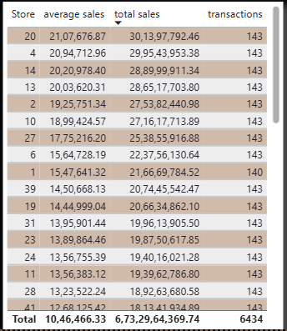
Figure 1: Store-level table used for validation (sorted by total sales)

6. Dashboard
The report has four pages: KPI Cards, Financial Visualization 1, Financial Visualization 2 and Financial Dashboard. The Financial Dashboard page combines the KPI cards, five charts and three slicers into a single interactive view.
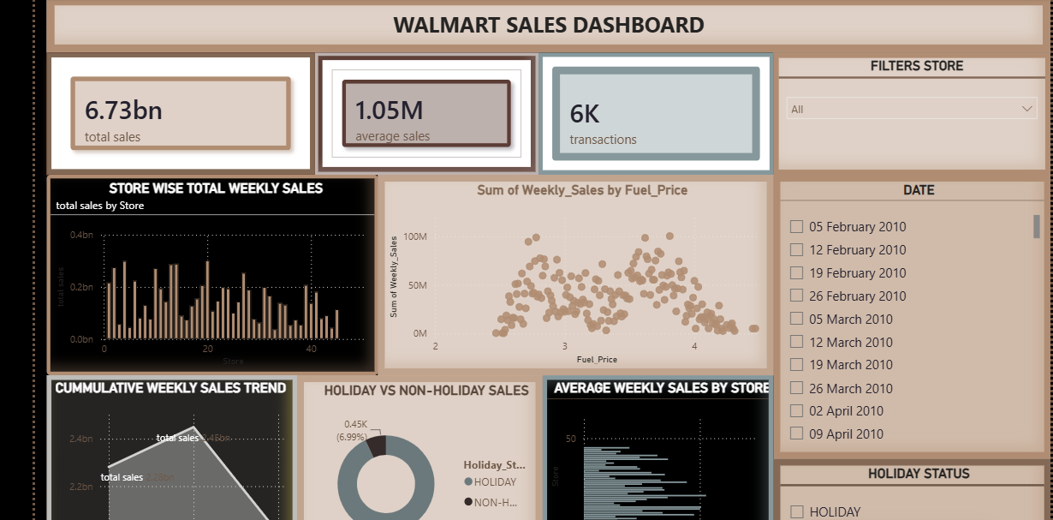
Figure 2: Walmart Sales Dashboard (Financial Dashboard page)
The dashboard allows the user to compare stores, follow sales over the years, compare holiday and non-holiday weeks, and study the effect of fuel price on sales. Slicers filter the whole page by store, date and holiday status.

7. Dashboard Components
Each visual provides a different view of the sales performance.

→ KPI Cards
Four KPI cards show the headline numbers: Total Sales (6.73bn), Average Sales (1.05M), Store Count (45) and Transactions (6K).
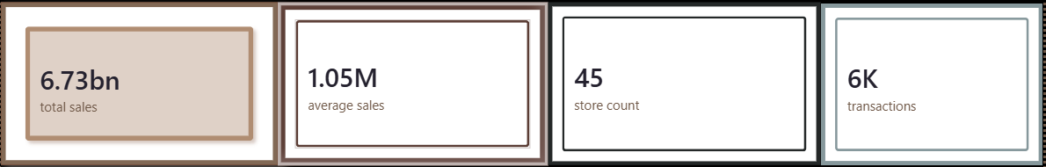
Figure 3: KPI cards
Purpose
- To show the key indicators at a glance.
- To summarise sales, store count and the number of records analysed.

→ Store Wise Total Weekly Sales
A Column Chart shows total sales for each store. Sales vary widely: the highest stores (such as Stores 4, 13, 14 and 20) reach about 0.3bn, while the lowest stores are below 0.05bn.
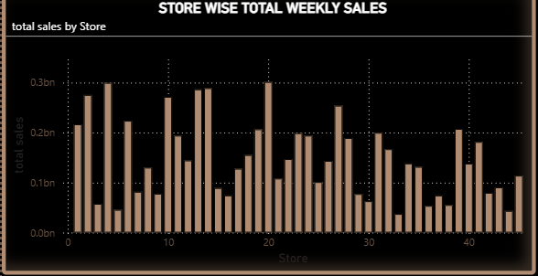
Figure 4: Store wise total weekly sales
Purpose
- To compare total sales across stores.
- To identify the strongest and weakest stores.

→ Average Weekly Sales by Store
A Bar Chart shows the average weekly sales of each store, ranging from roughly 0.25M to about 2.1M. It confirms that the stores with high totals also sell more in a typical week.
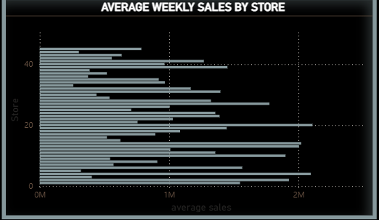
Figure 5: Average weekly sales by store
Purpose
- To compare typical weekly performance across stores.
- To separate consistently strong stores from smaller ones.

→ Yearly Sales Trend
A Line Chart shows total sales for each year. Sales rise from about 2.28bn in 2010 to a peak of about 2.45bn in 2011, then fall to about 2.0bn in 2012.
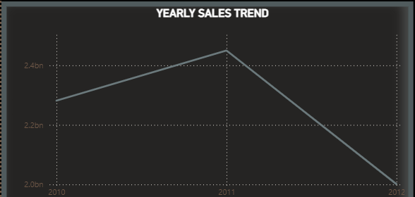
Figure 6: Yearly sales trend
Purpose
- To identify the long-term sales trend.
- To spot the peak and decline years.

→ Cumulative Weekly Sales Trend
An Area Chart presents the same yearly totals (2.28bn, 2.45bn and about 2.0bn) with data labels, giving a clearer visual of the rise and fall in sales over the three years.
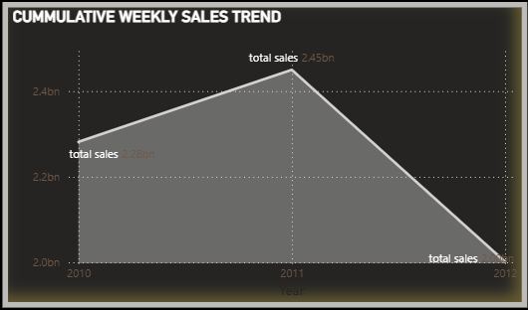
Figure 7: Cumulative weekly sales trend
Purpose
- To show how sales accumulate across years.
- To highlight the data labels for each year.

→ Holiday vs Non-Holiday Sales
A Donut Chart splits the 6,434 records by holiday status. As shown on the dashboard, 5.98K records (93.01%) are labelled HOLIDAY and 0.45K records (6.99%) are labelled NON-HOLIDAY.
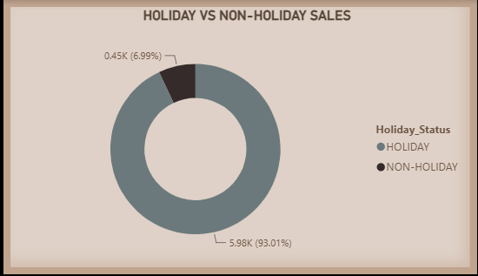
Figure 8: Holiday vs Non-Holiday
Purpose
- To compare the proportion of holiday and non-holiday weeks.
- To support the Holiday Status slicer.
Note: holiday weeks are normally a small minority of all weeks, so the labels on this chart appear to be reversed and should be checked in the data before final submission.

→ Store Ranking Over Time
A Ribbon Chart shows how each store ranks by total sales in 2010, 2011 and 2012. The ribbons show each store’s position and how it moves between years; most stores keep a similar position, with a few rank changes between 2010 and 2011.
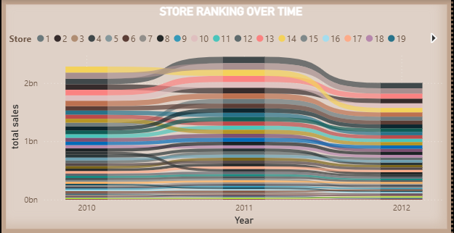
Figure 9: Store ranking over time
Purpose
- To track changes in store rank over time.
- To identify stores that are rising or falling.

→ Weekly Sales vs Fuel Price
A Scatter Plot shows the sum of weekly sales for each fuel price. Fuel prices range from about 2.5 to 4.5. The highest sales (about 100M) occur at prices around 2.8 and 3.6–3.8, and sales are lower and less frequent above 4.0. The points are widely scattered, so there is no clear straight-line relationship.
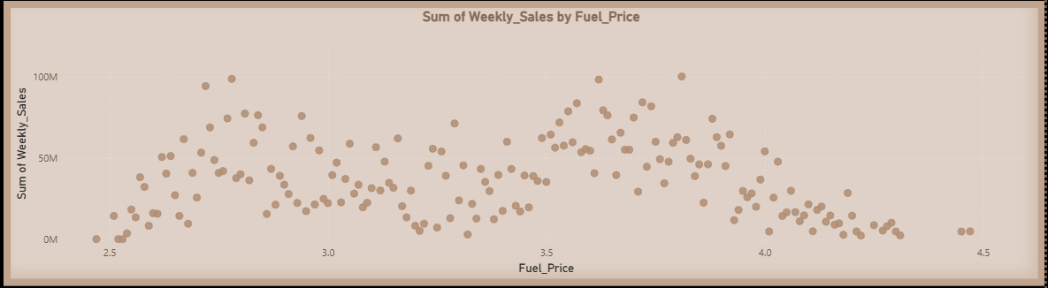
Figure 10: Sum of Weekly_Sales by Fuel_Price
Purpose
- To explore the effect of fuel price on sales.
- To identify price levels with higher or lower sales.

8. Slicers Used
Three slicers are included on the Financial Dashboard page:
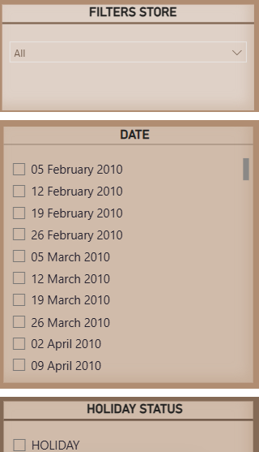
Figure 11: Store, Date and Holiday Status slicers
1. Store – A drop-down that lets the user select a particular store and analyse its performance.
2. Date – A list of weekly dates (starting 05 February 2010) that filters the dashboard to chosen weeks.
3. Holiday Status – Checkboxes for HOLIDAY and NON-HOLIDAY that filter the page by holiday status.
When a selection is made, the related charts and figures update. For example, the user can select one store and the holiday weeks to study how that store performs during holidays.

9. Key Findings
The major observations from the dashboard are:
Store | Avg Weekly Sales | Total Sales | Share of Total
Store 20 | 2.11M | 301.40M | 4.48%
Store 4 | 2.09M | 299.54M | 4.45%
Store 14 | 2.02M | 289.00M | 4.29%
Store 13 | 2.00M | 286.52M | 4.26%
Store 2 | 1.93M | 275.38M | 4.09%
Store 10 | 1.90M | 271.62M | 4.03%
Store 27 | 1.78M | 253.86M | 3.77%
Store 6 | 1.56M | 223.76M | 3.32%
Store 1 | 1.55M | 216.67M | 3.22%
Store 39 | 1.45M | 207.45M | 3.08%
Top 10 stores by total sales.
- Overall scale: Total sales of 6.73bn across 45 stores and 6,434 weekly records, an average of about 150M per store and 1.05M per store-week.
- Top stores: Store 20 leads with about 301M (4.5%), followed by Stores 4 and 14. The top 6 stores contribute about 26% of sales and the top 10 about 39%.
- Store gap: Total sales range from over 0.3bn for the best stores to under 0.05bn for the smallest, so store size and location matter greatly.
- Yearly trend: Sales grew by about 7% from 2010 to 2011 and then fell by about 18% in 2012. Part of this fall may be because the data covers fewer weeks in 2012; this should be verified against the date range.
- Fuel price: There is no clear linear link between fuel price and weekly sales; very high fuel prices appear only in a few weeks.
- Holiday data: The holiday donut shows 93% as holiday and 7% as non-holiday, which looks reversed and needs checking.
- Validation: Store-level totals match the KPI cards, confirming the measures are correct.
Note: values read from chart axes are approximate; exact figures are those shown in the KPI cards and the table.

10. Importance of the Dashboard
- Easy Data Understanding – Thousands of weekly records become easy to understand through KPI cards and charts.
- Quick Decision-Making – Total sales, average sales and store count are visible at a glance.
- Store Comparison – The store charts show which stores perform best and which need support.
- Trend Analysis – The yearly and cumulative charts show how sales change over time.
- Holiday Analysis – The holiday chart and slicer help study the effect of holidays on sales.
- Ranking Insights – The ribbon chart shows how store positions change from year to year.
- Interactive Analysis – Slicers allow filtering by store, date and holiday status.

11. Conclusion
The Walmart Sales Dashboard demonstrates how Microsoft Power BI can turn weekly retail data into an interactive and meaningful report. The project helped in understanding data preparation, DAX measures and validation, KPI cards, column, bar, line, area, donut and ribbon charts, scatter plots, tables and slicers.
The dashboard gives clear views of store performance, yearly trends, holiday weeks and fuel prices. It shows that a small group of stores generates a large share of sales, that sales peaked in 2011, and that fuel price has no clear straight-line effect on weekly sales. Overall, the project shows how Power BI can support effective sales performance analysis.

12. References
- Microsoft Power BI Desktop
- Walmart sales dataset (Dataset 1)
- Microsoft Power BI Documentation
- Microsoft DAX Documentation

